**Salesforce**

**The History of Salesforce - Salesforce News**

[salesforce.com](https://www.salesforce.com/news/stories/the-history-of-salesforce/)

16-20 minutes

*Editor’s note: This page was last updated in September 2020. For media inquiries about the history of Salesforce, please contact*[*PR@salesforce.com*](mailto:PR@salesforce.com)*.*

March 8, 2020 marked the 21st anniversary of Salesforce. It’s also a year that has brought tremendous challenges for all of our stakeholders as COVID-19 spread throughout the world. Our focus now is on keeping our employees and their families healthy and safe, supporting our communities, and helping our customers and partners navigate this crisis and prepare for a new normal. We’re grateful to everyone on the front lines of this crisis who is risking their own health to take care of the rest of us. This pandemic is a powerful reminder that we’re all connected like never before. For more information on the latest from Salesforce and our COVID-19 response go to the [Salesforce Newsroom](https://www.salesforce.com/company/news-press/press-releases/) and follow us [@SalesforceNews](https://twitter.com/SalesforceNews).

**21 Years of Salesforce News Highlights**

The timeline below shows the history of Salesforce over the years. It captures some milestones along the way, illustrating our record of doing well while doing good.

[Salesforce is the #1 CRM](https://www.salesforce.com/products/what-is-salesforce/), bringing companies and customers together in the digital age. Founded in 1999, Salesforce enables companies of every size and industry to take advantage of powerful technologies — cloud, mobile, social, blockchain, voice, and artificial intelligence — to connect to their customers in a whole new way.

**1999**

* In February, the Salesforce journey begins with a clear vision to be “A World-Class Internet Company for Sales Force Automation.”
* On March 8, Salesforce incorporates and Marc Benioff, Parker Harris, Frank Dominguez, and Dave Moellenhoff begin working on the first version of Salesforce’s CRM. Their base is a rented one-bedroom apartment at 1449 Montgomery Street, on San Francisco’s Telegraph Hill.
* As the four develop their prototype, they also build a distinctive startup culture. They only work on what they believe is important and necessary, to do it “fast, simple, and right the first time.” “No fluff” is [their mantra](https://www.salesforce.com/blog/2019/02/salesforce-san-francisco-1999.html). They wear Hawaiian print shirts, brunch at [Mama’s](http://www.mamas-sf.com/), appoint Marc’s dog Koa as Chief Love Officer, and constantly ask for feedback.
* The company also writes its first [V2MOM](https://www.salesforce.com/blog/2013/04/how-to-create-alignment-within-your-company.html) (Vision, Values, Methods, Obstacles, and Measures) strategic plan, aiming to provide employees with a clear vision and align the organization around common goals. In true startup fashion, the original draft is written on the back of an envelope. V2MOM remains at the core of how Salesforce runs its business, and continues to guide every decision the company makes.
* By the end of its first year, the company has expanded to 40 employees and an 8,000-square-foot office at the Rincon Center.

*Parker Harris personal video of the apartment where salesforce.com started*

**2000**

* Like many other tech companies, Salesforce endured challenges brought on by the dot-com bubble bursting, and 20% of the company’s workforce was laid off.
* On February 7, salesforce.com officially launches at an event themed around “The End of Software” at San Francisco’s Regency Theater with 1,500 attendees and a concert with The B-52s.
* In March, Salesforce gets a boost from its first piece of major press coverage, in *The Wall Street Journal*, when it hires actors to stage a mock protest outside a Siebel Systems conference. The “protestors” carry signs with anti-software messages to drive home Salesforce’s “The End of Software” marketing tagline.
* Salesforce.org launches the[1-1-1 model](https://www.salesforce.org/pledge-1/), leveraging its technology, people, and resources to improve communities around the world.
* In November, the growing business moves from the Rincon Center to a larger base at One Market Street.
* Revenue hits $5.4 million for fiscal year ending January 31, 2001.

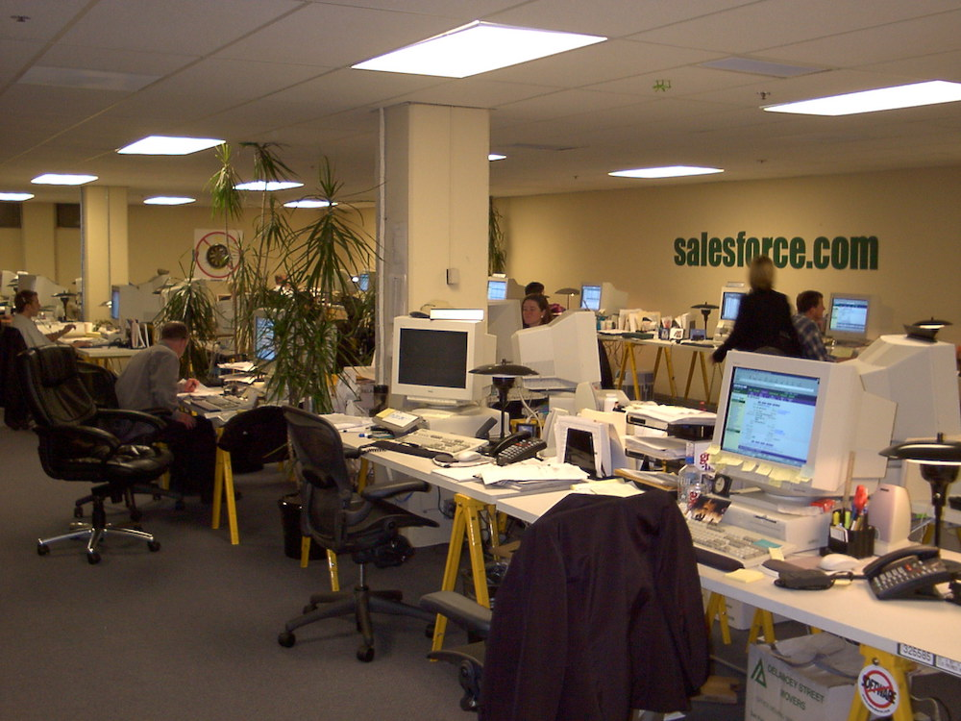

Download*An early Salesforce office circa 2000*

**2001**

* In April, Salesforce announces its expansion into the worldwide marketplace with headquarters in Dublin and Tokyo.
* Salesforce surpasses 3,000 customers, making it the fastest-growing CRM company.
* In November, Benioff is named Chief Executive Officer and Chairman.
* Salesforce delivers $22.4 million in revenue for the fiscal year, ending January 31, 2002.

**2002**

* By end of the year, the company has 5,740 customers, 70,000 users in 107 countries accessing the service in multiple currencies and eight languages.
* Salesforce delivers $51 million in revenue for the fiscal year, ending January 31, 2003.
* Marc Benioff makes a prediction about the future of Salesforce, CRM, and business: “There were the leaders, but Oracle displaced them. The same thing is going to happen again. It’s the beginning of a brand new technology and business world.”

**2003**

* The first [Dreamforce](https://www.salesforce.com/dreamforce/) event is held at the Westin St. Francis hotel in downtown San Francisco. Just over 1,000 registered attendees take part in the event, which has 52 presentations.
* sForce 2.0 — the industry’s first on-demand application service — is launched at the event.
* The company’s employees number more than 400.
* It establishes a global presence, opening offices in Australia, France, Germany, Ireland, Japan, Spain, and the U.K.
* Salesforce reaches almost $100 million in revenue by year end, files to go public in December.

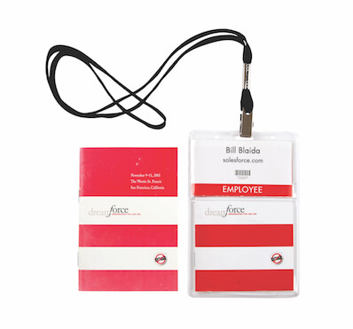

Download*Dreamforce badges from the inaugural Salesforce conference in 2003*

**2004**

* On June 23, Salesforce successfully completes its initial public offering on the New York Stock Exchange, raising $110 million at $11 per share.
* Salesforce earns $176 million in revenue over the fiscal year ending January 31, 2005.
* The company has 767 employees.
* The customer base has grown to 13,900.
* Some 8,000 developers and 150 independent software vendors are using Salesforce technologies to create apps.
* Salesforce has 12 offices around the world.

**2005**

* In September, Salesforce introduces its [AppExchange](https://appexchange.salesforce.com/) service, offering third-party developers a place to work on their own applications and open them up to Salesforce customers.
* By the end of the year, the company’s customer base stands at 20,500 worldwide, with nearly 400,000 unique users.
* The company surpasses 1,300 employees by end of fiscal year.
* It has earned $309.98 million in revenue for fiscal year ending January 31, 2006.

**2006**

* Salesforce’s mobile journey starts with the acquisition of wireless technology startup Sendia, and the original Salesforce mobile app, AppExchange Mobile.
* The AppExchange ecosystem grows into a vibrant marketplace with 575 apps from 250 independent software vendors.
* In a defining moment, Benioff shares his view that business is the greatest platform for change, publishing *The Business of Changing the World* with essays by 20 other thought leaders.
* The Power of Us partner program launches, engaging Salesforce’s partners with the 1-1-1 philanthropy model.
* Salesforce has 29,800 customers worldwide.
* Revenue tops $497 million for the fiscal year ending January 31, 2007.



Download*The Salesforce AppExchange circa 2006*

**2007**

* IdeaExchange (now[Trailblazer Community](https://success.salesforce.com/)) launches, inviting customers to contribute new feature ideas for future releases.
* At Dreamforce, plans for the Force.com technology platform are announced, which will allow developers to build applications on the Salesforce platform and create any user interface on demand.
* Salesforce reports revenue of $748.7 million for the fiscal year ending January 31, 2008.
* Users exceed 1.1 million, from 41,000 customers across the globe.
* The AppExchange community has 450 independent software vendor partners.
* Salesforce employees log 70,000 volunteer hours.

**2008**

* Salesforce has revenue of just over $1 billion for the fiscal year ending January 31 2009, making it the first cloud computing company to breach the billion-dollar mark in annual revenue.
* Forbes names Salesforce among the fastest-growing technology companies in the world.
* Number of customers grows to 55,400.
* Dreamforce in San Francisco reaches a new milestone, with 10,000 registered attendees.
* Force.com is released, making it easier for customers to build and install apps on Salesforce’s architecture.

**2009**

* Salesforce [launches Service Cloud](https://techcrunch.com/2009/01/14/salesforcecom-launches-the-service-cloud-a-customer-service-saas-application/), bringing customer service and support automation features to the market.
* Revenues rise by more than 20% to $1.3 billion for the fiscal year, ending January 31, 2010.
* Salesforce’s global customer base grows to 72,000 customers.
* The first application built on Force.com for the iPhone launches, and it’s the first enterprise partner on Apple’s App Store.
* Salesforce.org gives $14 million in grants to support nonprofits.
* Employees log more than 125,000 volunteer hours.
* Chairman and CEO Marc Benioff publishes [*Behind the Cloud*](https://salesforcestore.com/Behind-the-Cloud-P130.aspx), a memoir of Salesforce’s early days and growth to a company with $1 billion in annual revenues.



Download*An original Salesforce mascot called “SaaSy”*

**2010**

* Salesforce agrees to acquire [Heroku](https://www.salesforce.com/company/news-press/press-releases/2011/01/110104/), an application platform-as-a-service, to support for the next generation of app developers.
* Company finishes the fiscal year with more than 92,000 customers and 5,000 employees.
* Annual revenue rises to almost $1.66 billion for the fiscal year, ending January 31, 2011.
* Over the last ten years, Salesforce gave $23 million in grants, employees volunteered 255,000 hours, and 11,000 nonprofits had access to Salesforce products for free.
* *Fortune* magazine ranks Salesforce fourth on its list of the world’s fastest-growing companies.
* Salesforce is also named by the Ethisphere Institute as[one of the world’s most ethical companies](https://www.salesforce.com/company/news-press/press-releases/2010/03/100329/) for the fourth consecutive year.

**2011**

* Salesforce launches Chatter as a social collaboration service for the enterprise; more than 80,000 customers adopt Chatter in the first year.
* Salesforce extends its social enterprise capabilities to include marketing with the [acquisition](https://www.salesforce.com/company/news-press/press-releases/2011/05/110502/) of social media monitoring company, Radian6.
* Annual revenue rises 37% over the fiscal year to almost $2.27 billion, for the fiscal year ending January 31, 2012.
* By the end of the fiscal year, Salesforce employs 7,785 people around the globe.
* *Forbes* names Salesforce one of “The 50 Companies of Tomorrow,” taking notice of the innovation the company has achieved.

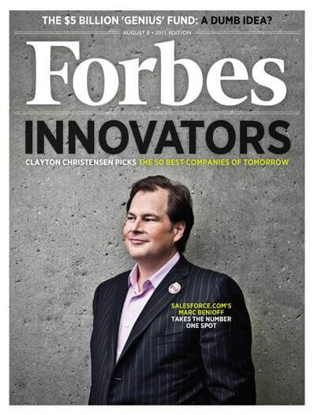

Download*Marc Benioff takes the number one spot on Fortune’s “The 50 Companies of Tomorrow” list*

**2012**

* Salesforce has more than $3 billion in annual revenue for the fiscal year ending January 31, 2013.
* The company has 9,800 employees in 22 offices around the world.
* The company also crosses a threshold with more than 100,000 customers.
* Salesforce leases space in the yet-to-be-built tower at 350 Mission Street as the plan for an urban campus takes shape.
* Dreamforce 2012 notches up 90,000 registered attendees. Salesforce Marketing Cloud is unveiled during the keynote address.
* *Forbes* selects Salesforce as the world’s most innovative company for the second consecutive year.
* Gartner ranks Salesforce #1 in CRM.

**2013**

* Salesforce completes its largest acquisition to date with ExactTarget, allowing it to supercharge the power of Marketing Cloud.
* The Salesforce1 Platform launches, empowering customers to run their business from their phone.
* Dreamforce has more than 143,000 registered attendees. A benefit concert during the event features the bands Blondie and Green Day.
* The AppExchange hosts more than 2,000 apps, and records over 2 million installs.
* Annual revenue over the fiscal year exceeds $4 billion for the fiscal year ending January 31, 2014.
* Salesforce has more than 13,300 employees worldwide.

**2014**

* Salesforce launches Trailhead, empowering anyone — regardless of education level — to develop the skills needed for top tech jobs.
* The company now has 1.5 million registered developers.
* Salesforce reaches the $5 billion in annual revenue milestone faster than any other enterprise software company.
* The company has more than 150,000 customers and 16,000 employees.
* Since its inception, the [Salesforce Foundation](https://www.salesforce.org/about-us/salesforce-foundation/) has donated $80 million and employees volunteered more than 840,000 hours.
* Salesforce Tower London opens.

**2015**

* Salesforce enters the Fortune 500.
* *Fortune* also recognizes Salesforce as one of the Top 10 Best Companies to Work For and one of the World’s Most Admired Software Companies.
* At Dreamforce, Salesforce announces new Lightning Experience, a completely new CRM experience.
* Salesforce unveils IoT Cloud, connecting billions of events from devices, sensors, apps and more from the Internet of Things to Salesforce.
* When San Francisco runs short of hotel rooms for Dreamforce attendees, Salesforce docks the ‘Dreamboat’ cruise ship to provide 1,000  extra accommodations.
* The company generates more than $6.66 billion in revenue for the fiscal year ending January 31, 2016.
* Salesforce has more than 150,000 customers worldwide and more than 20,000 employees.

**2016**

* Salesforce conducts its first equal pay assessment, resulting in $3 million in salary adjustments.
* Salesforce Tower opens in New York.
* The company acquires ecommerce platform Demandware to extend its Customer Success Platform to the retail industry, and introduces Commerce Cloud.
* Year-over-year revenue increases 26% to more than $8.4 billion for the fiscal year ending January 31, 2017.
* Salesforce has more than 25,000 employees across 25 countries.
* *Forbes* recognizes CEO Marc Benioff as “the decade’s top innovator.”
* The company acquires productivity software company Quip.
* Salesforce is named the #1 “Workplace for Giving Back” by *Fortune*.
* Salesforce.org has given $160 million in grants, logged 2 million employee volunteer hours, and more than 31,000 nonprofits and NGOs use the software for free or at a discount.

**2017**

* Salesforce launches Einstein, the first comprehensive artificial intelligence (AI) technology for CRM, making AI accessible to every company and business user.
* The company achieves net-zero greenhouse gas emissions and begins delivering a carbon-neutral cloud.
* mySalesforce is unveiled, allowing everyone from admins to business users to build and deploy modern, highly customized mobile apps with point-and-click tools.
* Revenue grows to $10.548 billion for the fiscal year ending January 31, 2018, up 25% on the previous year.
* Salesforce has 29,000 employees around the world and more than 150,000 customers.
* Ninety-five of the Fortune 100 run at least one app from the AppExchange.

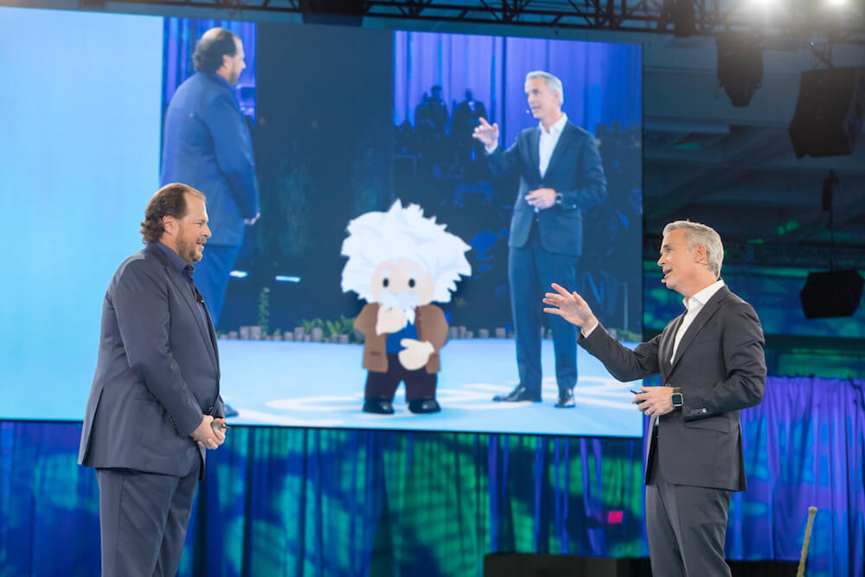Download*Salesforce launches Einstein, the first comprehensive artificial intelligence (AI) technology for CRM*

**2018**

* The Salesforce Tower in San Francisco has its grand opening.
* The company introduces Salesforce Customer 360, a new platform service that seamlessly manages customer data across clouds via a click-based user interface.
* Einstein Voice is introduced, empowering any user to talk to Salesforce.
* The company acquires MuleSoft to help power Salesforce’s integration capabilities. *Fortune* names Salesforce #1 on the 100 Best Companies to Work For list.
* The company has more than 36,000 employees.
* Revenue reaches $13.3 billion for the fiscal year ending January 31, 2019.

**2019**

* Salesforce acquires [Tableau](https://investor.salesforce.com/press-releases/press-release-details/2019/Salesforce-Completes-Acquisition-of-Tableau/default.aspx), bringing the world’s #1 CRM and #1 analytics platform together to supercharge customers’ digital transformations.
* Benioff’s book [*Trailblazer*](https://www.salesforce.com/trailblazerbook/) hits the shelves.
* More than 1.8 million learners are changing their lives on Trailhead.
* Dreamforce gathers Trailblazers from [120 countries and 50 U.S. states](https://www.salesforce.com/company/news-press/stories/2019/12/Dreamforce-By-Numbers/), with more than 171,000 registered attendees and 16 million online viewers.
* Annual revenue grew 29%, surpassing $17 billion for the fiscal year ending January 31, 2020.
* *Fortune* ranked Salesforce as one of its 100 Best Companies to Work for the 12th year in a row, one of the top 10 Most Admired Companies in the World and one of the Best Workplaces for Giving Back.
* Over the last two decades, Salesforce has given $330 million in grants to worthy causes, employees volunteered 4.9 million hours, and 46,000 nonprofits and NGO use the software for free or at a discount.

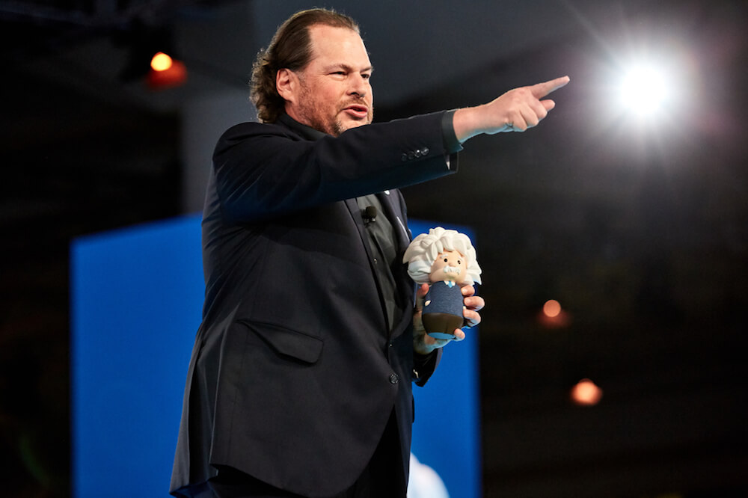

Download*Marc Benioff demos Einstein Voice capabilities at Dreamforce 2019*

**2020**

* Gartner ranks Salesforce  #1 in CRM for the 8th year in a row, gaining more share of market than the next nine competitors combined.
* Salesforce signs definitive agreement to [acquire Vlocity](https://www.salesforce.com/company/news-press/stories/2020/2/salesforce-news/), and the [acquisition closes](https://www.salesforce.com/company/news-press/stories/2020/6/salesforce-vlocity/) on June 1.
* Salesforce mobilizes around COVID-19, leveraging our products, resources, and relationships to help our communities navigate this crisis.
* Salesforce delivers more than [50 million units of personal protective equipment](https://www.nytimes.com/2020/04/28/business/coronavirus-marc-benioff-salesforce.html) to the frontline workers and healthcare facilities in need, and supports organizations locally and globally with our philanthropy.
* Salesforce employees have now logged [5 million volunteer hours](https://www.salesforce.com/company/news-press/stories/2020/4/salesforce-giving/).
* Salesforce launches [Work.com](https://www.salesforce.com/work/), all-new solutions to meet new workplace challenges. Work.com includes new solutions, ranging from contact tracing and emergency response management to employee wellness assessment and shift management, for accelerating private and public sector response to the COVID-19 pandemic.
* Salesforce is added to the Dow Jones Industrial Average, effective August 31, 2020.